UNIVERSITY OF ENGINEERING AND TECHNOLOGY JALOZAI PESHAWAR PAKISTAN

**“Flood Monitoring System”**

By

FAZAL HAMEED 19JZELE0339

ASFAND YAR ALI 19JZELE0343

FARAZ NAWAZ 19JZELE0346

The undersigned certify that they recommend to the UET Peshawar for acceptance of this thesis for the fulfillment of the requirements for the degree stated.

Supervisor: _______**Dr. Waqas Imtiaz**________________________

Signature: ______________________________________________

Final Year Project Coordinator: _______ **Engr. Najvia Khattak**_____________________

Signature: _____________________________________________

Chairman: ________ **Dr. Amjid Ali**___________________________

Signature: ______________________________________________

Date: _____________________________________________

**“Flood Monitoring System Using Wireless Sensor Network (WSN) & Internet of Things (IOT)”**

By

FAZAL HAMEED

ASFAND YAR ALI

FARAZ NAWAZ

A Thesis

Submitted to the UET Peshawar

as a Requirement for the Degree of

BACHELOR OF SCIENCE

DEPARTMENT OF ELECTRICAL ENGINEERING

UNVIVERSITY OF ENGINEERING AND TECHNOLOGY,

PESHAWAR, JALOZAI CAMPUS.

PAKISTAN

10/07/2023

**DEDICATION**

I begin by praising **Almighty Allah** for giving us guidance, strength, mental capacity, protection, skills, and a long and healthy life. I dedicate this study to Him, as it is through His blessings that we have been able to undertake this Endeavor.

This study is sincerely grateful for and acknowledges the moral, spiritual, emotional, and material support of our wonderful parents, who have been our constant inspiration and the source of our strength, especially during moments when we felt like giving up. Their unwavering belief in our abilities and their unconditional love have propelled us forward.

To our parents, grandparents, siblings, close friends, and classmates, who have provided advice, encouragement, and support throughout our Final Year Project, we express our heartfelt appreciation. Their presence and belief in our capabilities have been invaluable in our journey.

In particular, I want to extend my deepest thanks and recognition to my boss, **Dr. Waqas Imtiaz,** for his unending help, invaluable advice, and exceptional supervision. His unwavering support and willingness to dedicate his time whenever needed have played a crucial role in the successful completion of this study.

May Allah bless and reward all those who have contributed to this study, directly or indirectly, and may this work be of benefit to the scientific community and society as a whole.

**ACKNOWLEDGEMENTS**

First and foremost, we express our heartfelt gratitude to ALLAH (SWT), the All-Powerful, for His blessings and guidance throughout this research Endeavor. We firmly believe that this theory would not have come to fruition without His unwavering support.

We extend our sincere appreciation to the Electrical Engineering Department at the University of Engineering and Technology Peshawar - Jalozai Campus for their valuable contributions and assistance throughout our project. Their expertise and resources played a pivotal role in the successful completion of this thesis.

A special note of thanks goes to Dr. Waqas Imtiaz, our supervisor, for his continuous guidance, motivation, and unwavering support during the entire experimental process. His expertise and insights were instrumental in shaping this research work. We would also like to express our gratitude to Dr. Waqas Imtiaz for his invaluable assistance in preparing this thesis.

We would like to acknowledge the support and encouragement we received from our dear friends and colleagues. Their belief in our abilities and their unwavering support provided us with the necessary encouragement to overcome challenges and stay motivated throughout this journey.

Finally, we would like to express our deepest appreciation and heartfelt prayers to our families. Their unwavering support, love, and understanding have been the cornerstone of our lives. Without their constant encouragement and sacrifices, we would not have been able to complete this project.

We are sincerely grateful to all individuals and entities mentioned above, as well as those who have supported us behind the scenes. Their contributions and support have played a significant role in the successful completion of this thesis.

Thank You.

FAZAL HAMEED 19JZELE0339

ASFAND YAR ALI 19JZELE0343

FARAZ NAWAZ 19JZELE0346

**ABSTRACT**

Floods are natural disasters that have significant impacts on human lives, infrastructure, and the environment. Timely and accurate monitoring of flood conditions is crucial for effective disaster management and mitigation efforts. This project focuses on the development of a flood monitoring system utilizing Wireless Sensor Networks (WSN) and the Internet of Things (IoT) technology.

The objective of this study is to design and implement a robust and cost-effective flood monitoring system that can provide real-time data on water levels and water pressure. The system incorporates a network of wireless sensors strategically deployed in flood-prone areas to collect data and transmit it to a central server through IoT connectivity.

The proposed system utilizes various sensors to measure water levels and water pressure, providing comprehensive information for flood monitoring and early warning systems. The collected data is processed and analyzed in the central server, enabling the generation of timely alerts and visualizations to aid decision-making by relevant authorities and emergency responders.

The project also addresses the challenge of energy efficiency in WSN by employing techniques such as power management and sensor node. These measures ensure prolonged operational life and reduce maintenance requirements for the deployed sensor network.

Through the integration of WSN and IoT technologies, this flood monitoring system offers a scalable and adaptable solution that can be customized to different geographical regions and flood scenarios. By providing accurate and timely flood information, it enables proactive response strategies, facilitates efficient resource allocation, and ultimately helps mitigate the impact of flooding on vulnerable communities.

The effectiveness of the developed flood monitoring system will be evaluated through field tests and simulations, considering factors such as data accuracy, system reliability, and responsiveness. The results will contribute to the body of knowledge in the field of flood monitoring and support further improvements in disaster management practices.

Table of Contents

CHAPTER 01 xi

INTRODUCTION xi

1 INTRODUCTION xi

1.1 Motivation: xii

1.2 Overview: xiii

1.2.1 Expected Outcomes: xiii

CHAPTER 2 xiv

BACKGROUND xiv

2.0 BACKGROUND: xiv

2.1 Final Year Project Problem: xv

2.2 Final Year Project Objectives & Aims: xvi

2.3 Significance of Flood monitoring system using WSN and IoT: xvii

2.4 Engineer and Society: xviii

2.4.1 Engineers: xviii

2.4.2 Society: xix

2.5 Environment and Sustainability: xix

2.6 Area of Sustainable Development Goals: xx

CHAPTER 03 xxii

LITERATURE REVIEW xxii

3 INTRODUCTION xxii

3.1 WSN-based Flood Monitoring Systems: xxii

3.2 IoT-based Flood Monitoring Systems: xxiii

3.4 Challenges and Future Directions: xxiv

**2.6 Conclusion:** xxiv

CHAPTER 04 xxv

Methodology xxv

4 Introduction xxv

4.1 Design xxv

4.2 Hardware xxv

4.2.1 Three XBEE S2C Antennas xxv

4.2.2 Water Flow Sensor (YFS02) xxvi

4.2.3 LCD (Liquid Crystal Display) xxvi

4.2.4 Arduino Uno xxvii

4.2.5 Water Ultrasonic Sensor (HC-SR04 or Arduino Ultrasonic Sensor) xxviii

4.2.6 Variable Resistor (10k) xxix

4.2.7 XBEE USB Adapter for XBEE S2C Antenna xxix

4.2.8 XBEE Shield xxx

4.2.9 PCB xxx

4.3 Power Table for all components xxxi

4.4 Block Diagram xxxi

4.4 Flow Chart xxxii

4.4 Implementation xxxiii

**CHAPTER 05** xxxv

**Result and Discussion** xxxv

5 Introduction xxxv

5.1 Actual Hardware Results xxxv

5.1.1 Water Ultrasonic Sensor (HC-SR04 or Arduino Ultrasonic Sensor): xxxv

5.1.2 Water Flow Sensor (YFS02): xxxv

5.1.3 Arduino Uno: xxxv

5.1.4 LCD Crystal: xxxv

5.1.5 Variable Resistor (10k): xxxv

5.1.5 XBEE S2C Antennas (Coordinator, Router, and End-Device): xxxvi

5.1.6 XBEE USB Adapter: xxxvi

Figure (5.2.2) output on end device xxxviii

5.3 Discussion xxxviii

5.4 Comparative Analysis xxxix

5.5 Conclusion xxxix

CHAPTER 06 xl

CONCLUSIONS AND FUTURE Work xl

6.1 Important Findings xl

6.2 Conclusion xl

6.3 Limitations of the System xl

6.4 Future Recommendations xli

References xlii

Appendices xliii

Code of Sensor and XBEE xliii

LIST OF FIGURES

Figure (4.2.1) XBee device ________________________________________________xxv

Figure (4.2.2) Flow sensor _________________________________________________xxvi

Figure (4.2.3) LCD _______________________________________________________xxvii

Figure (4.2.4) Arduino Uno _________________________________________________xxvii

Figure (4.2.5) Ultrasonic sensor _____________________________________________xxviii

Figure (4.2.6)Variable Resistor (10k)_______________________________________________ xxix

Figure (4.2.7) XBee USB Adapter ___________________________________________xxix

Figure (4.2.8) XBee Shield________________________________________________ xxx

Figure (4.2.9) PCB board __________________________________________________xxx

Figure (4.4) Block Diagram ________________________________________________xxxi

Figure (4.4) flow chart____________________________________________________ xxxii

Figure (4.4) Circuit implementation _________________________________________xxxiii

Figure (5.1.7) LCD output ________________________________________________xxxvi

Figure (5.2.1) Serial monitor output________________________________________ xxxvii

Figure (5.2.2) output on coordinator Xbee ___________________________________xxxvii

Figure (5.2.2) output on router Xbee ________________________________________xxxviii

Figure (5.2.2) output on end device ________________________________________ xxxviii

# LIST OF TABLES

# Table (4.2.1) Information about XBee module ________________________________xxvi

Table (4.2.2) Specifications for YFS02 Sensor Measurement ______________________xxvi

Table (4.2.3) Specification of Arduino uno ____________________________________xxvii

Table (4.2.4) Specifications of ultrasonic sensor ________________________________xxvii

Table (4.3) power table ___________________________________________________xxxi

# LIST OF ABBREVIATIONS

# 

FYP – Final Year Project

WSN – Wireless Sensor Network

IOT – Internet of Things

LCD – Liquid Crystal Display

SDG - Sustainable Development Goals

mA - Milliamperes

TTL – Time To Live

kHz – kilo hertz

# CHAPTER 01

# INTRODUCTION

## 1 INTRODUCTION

Flooding is a major and devastating disaster that affects numerous regions around the world [1-2]. It occurs when water surpasses the capacity of rivers, dams, lakes, or as a result of heavy rainfall. Pakistan, being a flood-prone country, experiences the detrimental effects of flash floods at regular intervals. The unique geo-climatic conditions in Pakistan, particularly the northern region, contribute to heavy rainfall and subsequent flash floods that affect vast areas across the country. These flash floods pose a significant threat to the population, as they can carry away homes, vehicles, and even people, causing the loss of property and lives [3].

In addition to the immediate dangers, flash floods in Pakistan also lead to various long-term problems. One of the major issues is the disruption of transportation infrastructure due to flooded roads. This results in heavy traffic congestion, causing significant delays and inconveniences for both motorists and commuters. The current flood monitoring and warning systems in place rely on manual and outdated techniques, leading to delayed warnings and incomplete response measures [5-6]. Furthermore, these methods are costly and impractical for a developing country like Pakistan [4-5].

To address these challenges, there is a pressing need for an efficient and cost-effective flood monitoring system that utilizes advanced technologies. In recent years, Wireless Sensor Networks (WSNs) and Internet of Things (IoT) sensors have emerged as promising solutions for monitoring various environmental conditions. By leveraging WSN and IoT technologies, a flood monitoring system can offer numerous advantages, such as low cost, convenient monitoring arrangements, accurate detection, and high accountability. Moreover, the hybrid network of ad-hoc and infrastructure mode networks enhances the robustness of the monitoring system [5-6].

While both WSNs and IoT sensors have their limitations, their combined use can provide comprehensive flood monitoring coverage across Pakistan. However, the remote nature of flood-prone areas presents challenges in terms of power supply and efficient sensor node placement. Overcoming these challenges requires a self-sustainable architecture that utilizes renewable energy sources and node placement. By developing such a flood monitoring system, it becomes possible to provide real-time monitoring and early warnings to flood-prone regions, even in the absence of reliable telecom infrastructure [7].

This project aims to address the aforementioned challenges and develop a flood monitoring system specifically tailored to the needs of Pakistan's flood-prone areas. The proposed system will utilize self-sustaining sensor nodes powered by renewable energy technologies.

By implementing this flood monitoring system, the project aims to not only enable real-time monitoring using affordable and sustainable resources but also provide vital information even in areas lacking adequate telecom infrastructure. Ultimately, this system has the potential to save lives by delivering timely warnings and crucial information in the event of unfortunate flooding incidents.

## 1.1 Motivation:

The motivation behind developing a flood monitoring system using Wireless Sensor Networks (WSNs) and Internet of Things (IoT) sensors stems from the urgent need to address the devastating impact of floods in Pakistan [5]. As a flood-prone country, Pakistan has experienced countless instances of flash floods that result in loss of lives, destruction of infrastructure, and long-term socioeconomic setbacks. The existing manual and obsolete flood monitoring techniques have proven insufficient in providing timely warnings and facilitating effective disaster management.

The primary motivation for this project is to leverage the potential of WSNs and IoT sensors to revolutionize flood monitoring in Pakistan. By harnessing the power of these advanced technologies, we can overcome the limitations of traditional monitoring methods and create a more robust and efficient system. The proposed flood monitoring system offers several compelling advantages, including cost-effectiveness, real-time monitoring, accurate detection, and high accountability [12].

One of the key motivating factors is the dire need to improve the timeliness of flood warnings. By implementing a WSN and IoT-based system, we aim to provide faster and more accurate flood alerts to vulnerable communities. Timely warnings enable people to evacuate in advance, take necessary precautions, and minimize the loss of life and property. This project seeks to bridge the gap between flood occurrence and the dissemination of critical information, reducing response time and ensuring a proactive approach to flood management.

Another motivation lies in the economic constraints faced by developing countries like Pakistan. The current flood monitoring systems used in developed countries are often expensive, relying on costly equipment and expert hydrologists. Such resources are impractical and unaffordable for a country like Pakistan, where efficient and low-cost solutions are required to tackle the recurring flood challenges. By leveraging the cost-effectiveness of WSNs and IoT sensors, this project aims to provide an affordable flood monitoring system that can be implemented on a larger scale, benefiting vulnerable regions across Pakistan.

Furthermore, the motivation behind this project is rooted in the potential to optimize sensor node placement and utilize renewable energy sources. By strategically deploying sensor nodes in flood-prone areas and ensuring a continuous power supply through renewable energy technologies, we can enhance the reliability and sustainability of the flood monitoring system. The optimization techniques employed in this project aim to minimize costs while maximizing the coverage and effectiveness of the system, ensuring that resources are utilized efficiently and effectively.

Ultimately, the motivation behind developing a flood monitoring system using WSNs and IoT sensors is driven by the desire to save lives, protect infrastructure, and mitigate the devastating impact of floods in Pakistan. By leveraging cutting-edge technologies, this project strives to revolutionize flood monitoring and early warning systems, providing valuable data and insights to empower decision-makers, emergency responders, and the affected communities.

## 1.2 Overview:

The proposed flood monitoring system utilizing Wireless Sensor Networks (WSNs) and Internet of Things (IoT) sensors aims to revolutionize the existing flood monitoring and early warning systems in flood-prone regions of Pakistan [5]. This overview provides a high-level summary of the key components, objectives, and expected outcomes of the project.

### 1.2.1 Expected Outcomes:

The successful implementation of the flood monitoring system is anticipated to yield the following outcomes:

* Timely and accurate flood warnings: The system will enable real-time monitoring, data analysis, and early warning generation, allowing for timely evacuation and disaster preparedness.
* Cost-effectiveness: The utilization of WSNs and IoT sensors will provide a cost-effective solution, making flood monitoring accessible and sustainable in resource-constrained settings.
* Improved infrastructure resilience: By providing valuable data on flood patterns and severity, the system will aid in designing and implementing infrastructure resilient to flooding, reducing future damages.
* Enhanced decision-making: Real-time monitoring and data analytics will facilitate informed decision-making for emergency responders, local authorities, and policymakers, improving disaster response and management strategies.

In conclusion, the proposed flood monitoring system using WSNs and IoT sensors offers an innovative and cost-effective approach to address the challenges of flood monitoring in Pakistan. By leveraging advanced technologies, this project aims to enhance early warning systems, reduce flood-related risks, and improve the resilience of flood-prone regions.

## 

## CHAPTER 2

## BACKGROUND

## 2.0 BACKGROUND:

Flooding is a pervasive and recurring natural disaster that affects numerous regions worldwide, causing extensive damage to infrastructure, loss of lives, and significant socioeconomic setbacks. Pakistan, located in South Asia, is particularly vulnerable to floods due to its unique geo-climatic conditions. The country experiences both riverine floods, caused by overflowing rivers and heavy monsoon rains, and flash floods, resulting from intense rainfall in hilly areas [4].

Flash floods, in particular, pose a significant threat to Pakistan's population and infrastructure. The northern part of the country, encompassing the mountainous regions, is highly prone to flash floods due to its topography and torrential rains. The rapid onset and unpredictability of flash floods make them especially dangerous, often resulting in high casualty rates and extensive property damage.

The current flood monitoring systems in Pakistan rely primarily on manual and outdated techniques, making them insufficient in providing timely warnings and facilitating effective disaster management. The issuance of late warnings, inadequate monitoring coverage, and a lack of reliable infrastructure contribute to the challenges faced in mitigating the impact of floods.

Moreover, the economic constraints faced by developing countries like Pakistan pose a significant barrier to implementing advanced flood monitoring systems. The cost associated with acquiring and maintaining sophisticated monitoring equipment, as well as the need for expert hydrologists to interpret the data, makes the existing flood monitoring methods impractical and unaffordable.

In recent years, Wireless Sensor Networks (WSNs) and Internet of Things (IoT) sensors have emerged as promising technologies for environmental monitoring applications [5]. WSNs consist of numerous autonomous sensor nodes that can sense, process, and communicate data wirelessly. IoT sensors, on the other hand, are capable of collecting and transmitting data from various physical parameters, creating a network of interconnected devices.

The integration of WSNs and IoT sensors into flood monitoring systems offers several advantages [7]. These technologies enable real-time data collection, remote monitoring, and the ability to cover large geographical areas. Furthermore, WSNs and IoT sensors provide cost-effective solutions, reducing the reliance on manual labor and expensive infrastructure.

By leveraging the capabilities of WSNs and IoT sensors, it becomes possible to develop an efficient and affordable flood monitoring system for Pakistan. Such a system can provide real-time monitoring, early warnings, and valuable data for effective decision-making.

By strategically deploying sensor nodes, the system can effectively capture data on water levels and water pressure, facilitating accurate flood detection and timely warning dissemination.

In conclusion, the adoption of WSNs and IoT sensors in flood monitoring systems offers a promising solution to address the challenges faced in Pakistan. By leveraging these advanced technologies, it is possible to overcome the limitations of manual techniques, improve the timeliness of flood warnings, and enhance the resilience of flood-prone regions.

## 2.1 Final Year Project Problem:

The final year project aims to address the problem of inadequate and outdated flood monitoring systems in flood-prone regions of Pakistan. The existing manual techniques used for flood monitoring have proven to be inefficient and ineffective in providing timely warnings and facilitating effective disaster management. Additionally, the high cost associated with sophisticated monitoring systems renders them impractical for a developing country like Pakistan. Therefore, there is a critical need to develop an innovative and cost-effective flood monitoring system using Wireless Sensor Networks (WSNs) and Internet of Things (IoT) sensors.

The specific problems that this project aims to tackle are as follows:

* Incomplete Warning Systems: The current flood monitoring systems in Pakistan have problems with issuing timely warnings. The way they collect and interpret data takes a long time and doesn't give real-time updates on flood conditions. Because of this, communities at risk don't get enough warning to evacuate on time, which increases the chances of people getting hurt and property getting damaged.
* Limited Monitoring Coverage: The existing flood monitoring systems have limited coverage, especially in remote and inaccessible areas. This results in a lack of comprehensive data on flood conditions, hindering effective disaster response and management. There is a need to extend the monitoring coverage to ensure timely and accurate information about flood events across the country.
* Cost Constraints: Developing countries like Pakistan face economic constraints, making it challenging to implement and maintain expensive flood monitoring systems. The high cost of equipment, infrastructure, and expert human resources limits the scalability and accessibility of flood monitoring solutions. Therefore, there is a need for a cost-effective system that utilizes affordable technologies and optimized resource allocation.
* Low power consumption: Usually flood monitoring system uses a high power consumption that's why in flood occurring areas it may not give us the real time values that's why we design a low power consumption flood monitoring system which gives us the correct real time values.

By addressing these problems, the final year project aims to develop a flood monitoring system using WSNs and IoT sensors that provides timely warnings, extensive coverage, cost-effectiveness, and sustainable operation. The proposed system will overcome the limitations of manual techniques, improve the accuracy and timeliness of flood warnings, and enhance the resilience of flood-prone regions in Pakistan.

## 2.2 Final Year Project Objectives & Aims:

The primary objectives and aims of the final year project on developing a flood monitoring system using Wireless Sensor Networks (WSNs) and Internet of Things (IoT) sensors are as follows:

* Develop a Robust Flood Monitoring System: The project aims to design and implement a robust flood monitoring system that can accurately detect and monitor flood events in real-time. The system will utilize WSNs and IoT sensors to collect data on water levels, rainfall intensity, weather conditions, and other relevant parameters. The objective is to create a reliable and comprehensive monitoring infrastructure that enables early flood detection and timely warning generation [4-5].
* Ensure Timely and Accurate Flood Warnings: The project aims to improve the timeliness and accuracy of flood warnings by leveraging real-time data collection and analysis. By utilizing WSNs and IoT sensors, the system will provide continuous monitoring and analysis of flood-related parameters. The objective is to develop algorithms and models that can effectively process the collected data and generate timely warnings to at-risk communities, enabling them to take proactive measures for evacuation and flood preparedness.
* The final year project aims to develop a low-cost wireless sensor system for flood monitoring. The objectives include deploying sensors to measure water levels, developing real-time data collection, implementing an early warning system, and creating a user-friendly interface. The project seeks to improve flood monitoring capabilities, provide timely alerts, and minimize casualties and property damage through an affordable and accessible solution.
* The final year project aims to develop a wireless sensor system for measuring water level and flow. The objectives include deploying sensors to accurately measure these parameters, developing wireless communication capabilities, implementing data visualization on a wireless module, and providing real-time monitoring of water conditions. The project seeks to enable remote measurement and demonstration of water level and flow data through an accessible and wireless platform.
* This project will design a flood monitoring and alert system that is low cost and is able to measure various flood parameters such as the water level and water flow in real time [9]. In addition, this system will predict the flood disaster and send the real time data to the coordinator, router and end device.

In conclusion, the objectives and aims of the final year project revolve around developing an advanced flood monitoring system using WSNs and IoT sensors. The project aims to improve the accuracy and timeliness of flood warnings, optimize sensor node placement, establish self-sustainable operations, ensure effective communication infrastructure, and enhance decision support for disaster management [12]. By achieving these objectives, the project aims to contribute to the resilience and safety of flood-prone regions in Pakistan project aims to contribute to the resilience and safety of flood-prone regions in Pakistan.

## 2.3 Significance of Flood monitoring system using WSN and IoT:

The development of a flood monitoring system using Wireless Sensor Networks (WSNs) and Internet of Things (IoT) sensors holds significant importance and offers numerous benefits for flood-prone regions like Pakistan. The project's significance lies in the following aspects:

* Early Warning and Risk Reduction: By implementing an advanced flood monitoring system, the project aims to provide timely and accurate flood warnings to vulnerable communities. Early warning systems are crucial in reducing the risk of casualties and property damage during floods. The real-time data collection and analysis capabilities of WSNs and IoT sensors enable proactive measures and evacuation planning, ultimately saving lives and minimizing the impact of floods.
* Improved Disaster Preparedness and Response: The flood monitoring system enhances disaster preparedness and response capabilities. It provides valuable data on water levels, rainfall patterns, and weather conditions, enabling emergency responders and local authorities to make informed decisions and allocate resources effectively. The system's integration with decision support tools and visualization techniques aids in developing robust disaster management strategies and optimizing response efforts.
* Enhanced Resilience and Adaptation: The project contributes to the resilience and adaptation of flood-prone regions. The comprehensive monitoring coverage provided by WSNs and IoT sensors helps identify vulnerable areas and assess flood risks more accurately. This information facilitates the implementation of targeted mitigation measures, such as constructing flood-resistant infrastructure, improving drainage systems, and developing appropriate land use policies to minimize the impact of floods on communities and the environment.
* Cost-Effectiveness and Affordability: The use of WSNs and IoT sensors offers a cost-effective alternative to traditional flood monitoring systems. By leveraging wireless communication and self-sustainable operations, the project reduces the reliance on expensive infrastructure and manual labor. This cost-effective approach makes flood monitoring systems more accessible and feasible, particularly for developing countries like Pakistan with limited financial resources[8-9].
* Data-driven Decision Making: The flood monitoring system generates a wealth of real-time data on flood conditions and related parameters. This data can be utilized for data-driven decision making, both during and after flood events. It enables policymakers, researchers, and planners to analyze historical trends, identify patterns, and develop evidence-based strategies for flood mitigation, urban planning, and climate change adaptation.
* Technological Innovation and Knowledge Advancement: The project contributes to technological innovation and knowledge advancement in the field of flood monitoring. By utilizing WSNs, IoT sensors, and optimization techniques, the project explores cutting-edge technologies and methodologies. The research outcomes, insights, and lessons learned from this project can potentially contribute to the advancement of flood monitoring systems globally, benefiting other flood-prone regions facing similar challenges.

The development of a flood monitoring system using WSNs and IoT sensors brings significant benefits in terms of early warning, disaster preparedness, resilience, cost-effectiveness, data-driven decision making, and technological innovation. The project's significance lies in its potential to save lives, reduce damages, enhance community resilience, and contribute to the sustainable development of flood-prone regions like Pakistan.

## 2.4 Engineer and Society:

The improvement of a flood monitoring device the use of wi-fi Sensor Networks (WSNs) and internet of things (IoT) sensors has tremendous implications for each engineers and society. Engineers play a vital function in designing, imposing, and preserving such systems, even as society blessings from the improved flood tracking competencies and more suitable disaster preparedness. right here's how engineers and society are impacted:

### 2.4.1 Engineers:

* Technological information: Engineers concerned inside the improvement of the flood tracking gadget gain knowledge in WSNs, IoT sensors, records analysis, verbal exchange networks, and optimization strategies. They acquire valuable capabilities and knowledge in implementing 5bf1289bdb38b4a57d54c435c7e4aa1c technologies and addressing the challenges associated with flood monitoring.
* Innovation and studies: Engineers make a contribution to technological innovation by means of exploring new procedures, algorithms, and methodologies to enhance flood monitoring structures. Their research and improvement efforts purpose to enhance the accuracy, reliability, and cost-effectiveness of the gadget, pushing the boundaries of understanding on this area.
* moral concerns: Engineers have a responsibility to do not forget ethical implications all through the undertaking's lifecycle. This consists of ensuring facts privacy, minimizing environmental impact, and addressing capability social inequities within the deployment and accessibility of the flood tracking gadget.

### 2.4.2 Society:

a. progressed Flood Preparedness: The flood tracking gadget enhances society's capability to prepare for and reply to flood activities. well timed and accurate flood warnings enable groups to take proactive measures, consisting of evacuations, useful resource allocation, and emergency response planning. This improves public protection, reduces casualties, and minimizes assets damage.

b. Resilience and edition: The flood monitoring gadget contributes to society's resilience and adaptation to floods. by using offering complete tracking insurance and real-time statistics, it allows proof-based choice-making for flood mitigation strategies, city making plans, and weather trade variation measures. This allows groups develop sustainable infrastructure and land use rules that could withstand future flood events.

In precis, engineers contribute their technical information, innovation, and ethical issues to increase and keep the flood monitoring device. Society benefits from progressed flood preparedness, resilience, and model. The collaboration between engineers and society ends in the creation of powerful answers that address the challenges of flood tracking, creating a fine impact on individuals, groups, and the general nicely-being of society.

## 2.5 Environment and Sustainability:

The development of a flood monitoring system using Wireless Sensor Networks (WSNs) and Internet of Things (IoT) sensors has important implications for the environment and sustainability. This innovative system can contribute to environmental conservation, resource efficiency, and sustainable practices. Here's how the flood monitoring system aligns with environmental considerations and promotes sustainability:

* Environmental Data Collection: The flood monitoring system collects valuable data, such as water levels and water pressure. This data contributes to a better understanding of the natural environment and supports research on flood dynamics, water resource management. It aids in identifying environmental patterns and trends, facilitating informed decision-making for sustainable development.
* Conservation of Natural Resources: The implementation of WSNs and IoT sensors for flood monitoring promotes resource efficiency. These technologies enable remote monitoring and data collection without the need for extensive physical infrastructure or manual interventions. By minimizing the use of traditional monitoring equipment and reducing energy consumption, the system helps conserve natural resources and mitigates environmental impact.
* Climate Change Adaptation: With the increasing frequency and intensity of climate-related events, including floods, the flood monitoring system plays a crucial role in climate change adaptation. By providing real-time data on flood events, the system supports evidence-based decision-making for adapting to changing climatic conditions. This can include developing resilient infrastructure, implementing sustainable land use practices, and enhancing community preparedness for future flood events.
* Mitigation of Environmental Impacts: Early detection and timely warnings facilitated by the flood monitoring system can help mitigate the environmental impacts of floods. By enabling proactive measures such as evacuation, resource allocation, and emergency response planning, the system helps protect ecosystems, wildlife habitats, and sensitive environmental areas from the destructive forces of floods. It contributes to the preservation of biodiversity and the restoration of affected ecosystems.
* Environmental Awareness and Education: The implementation of the flood monitoring system can raise public awareness about flood risks and environmental challenges. By providing accessible and understandable information, the system helps educate individuals and communities about the importance of environmental stewardship, sustainable practices, and climate resilience. This fosters a sense of environmental responsibility and encourages behavioral changes that contribute to long-term sustainability.

The flood monitoring system using WSNs and IoT sensors promotes environmental conservation, resource efficiency, and sustainability. It facilitates data collection for environmental research, conserves natural resources, utilizes sustainable energy sources, supports climate change adaptation, mitigates environmental impacts, and fosters environmental awareness. By incorporating environmental considerations and sustainability principles, the system contributes to a more resilient and sustainable future.

## 2.6 Area of Sustainable Development Goals:

The development of a flood monitoring system using Wireless Sensor Networks (WSNs) and Internet of Things (IoT) sensors aligns with several Sustainable Development Goals (SDGs) established by the United Nations. The flood monitoring system contributes to addressing the following SDGs:

* SDG 6: Clean Water and Sanitation: The flood monitoring system helps in monitoring water levels and water pressure, thereby supporting effective water resource management. It enables early detection of floods, ensuring timely response and reducing the impact on water sources. By promoting efficient water management and reducing water-related risks, the system supports SDG 6.
* SDG 9: Industry, Innovation, and Infrastructure: The flood monitoring system relies on innovative technologies, such as WSNs and IoT sensors, to enhance flood monitoring capabilities. It contributes to the development of resilient infrastructure and promotes technological innovation for disaster risk reduction. By integrating advanced infrastructure and monitoring systems, the system supports SDG 9.
* SDG 11: Sustainable Cities and Communities: The flood monitoring system aids in urban planning and resilient infrastructure development. It provides real-time data for flood-prone areas, supporting evidence-based decision-making and risk assessment for sustainable urban development. By enhancing disaster preparedness and reducing the vulnerability of cities and communities to floods, the system aligns with SDG 11.
* SDG 13: Climate Action: The flood monitoring system plays a crucial role in climate change adaptation and mitigating the impact of floods. By providing accurate and timely data on flood events, it supports climate resilience planning, disaster response, and the implementation of climate change adaptation strategies. The system contributes to SDG 13 by enhancing climate action efforts.
* SDG 15: Life on Land: The flood monitoring system aids in the protection of ecosystems and biodiversity by facilitating early detection and response to floods. By minimizing the environmental impact of floods, the system helps preserve terrestrial habitats, wildlife, and natural resources. It supports SDG 15 by promoting the conservation of life on land.
* SDG 17: Partnerships for the Goals: The development and implementation of the flood monitoring system require collaboration and partnerships among various stakeholders, including engineers, government agencies, communities, and researchers. By fostering partnerships, knowledge sharing, and cooperation, the system contributes to the achievement of SDG 17 and supports collective action for sustainable development.

The flood monitoring system using WSNs and IoT sensors aligns with SDGs related to clean water and sanitation, industry and innovation, sustainable cities and communities, climate action, life on land, and partnerships for the goals. By addressing these SDGs, the system promotes sustainable development, resilience, and effective disaster risk reduction, contributing to a more sustainable and equitable future.

# CHAPTER 03

# LITERATURE REVIEW

## 3 INTRODUCTION

## Floods are a major concern worldwide, posing significant risks to communities. They result in the loss of lives, damage to infrastructure, and substantial economic losses. To address these challenges, the development of effective flood monitoring systems is crucial. In recent years, there has been growing interest in leveraging Wireless Sensor Networks (WSNs) and Internet of Things (IoT) sensors for flood monitoring. This literature review aims to explore and analyze existing research and publications related to flood monitoring systems using WSNs and IoT sensors. Additionally, it aims to uncover any gaps or limitations in the existing flood monitoring systems, which can inform the development of a more robust and comprehensive solution. By utilizing WSNs and IoT sensors, flood monitoring systems can provide real-time data on various parameters such as water level and water flow. These systems enable continuous and remote monitoring of flood-prone areas, allowing for early warning systems and prompt emergency responses. Ultimately, the findings of this literature review will contribute to the development of an improved flood monitoring system, addressing the identified gaps and leveraging the latest advancements in WSNs and IoT sensors. This system has the potential to enhance flood preparedness, response, and mitigation efforts, ultimately minimizing the impact of floods on communities and infrastructure.

## 3.1 WSN-based Flood Monitoring Systems:

WSN-based flood monitoring systems are sophisticated solutions designed to detect and monitor flood events in flood-prone areas. These systems leverage the power of wireless sensor networks, integrating a multitude of sensor nodes strategically placed throughout the region of interest. Each sensor node is equipped with various sensors, including water level sensors, rain gauges, temperature sensors, and humidity sensors.

The sensor nodes form a network infrastructure, enabling them to communicate with each other and relay data to a central base station or sink node. This wireless communication is typically achieved using protocols such as Zigbee, Bluetooth, or Wi-Fi. The sensor nodes continuously collect data from their respective sensors, which is then transmitted wirelessly to the base station.

At the base station, the collected data is processed and analyzed to identify and assess flood events. Advanced algorithms and techniques are employed to analyze parameters such as water levels, rainfall intensity, and weather conditions. By monitoring these factors in real-time, the system can detect the onset of a flood event or predict the likelihood of a flood occurrence.

One of the key advantages of WSN-based flood monitoring systems is their ability to provide real-time monitoring and early warning capabilities. When a flood event is detected or predicted, the system can issue alerts and warnings through various communication channels. This ensures that authorities and relevant stakeholders receive timely information, allowing them to initiate evacuation plans and emergency responses promptly.

To aid in data interpretation and decision-making, WSN-based flood monitoring systems often include user interfaces or web-based dashboards. These interfaces present the collected data in a visual and intuitive manner, allowing users to easily understand the flood-related information. Additionally, historical data and reports can be generated, facilitating flood management strategies and future planning.

Scalability and reliability are crucial aspects of WSN-based flood monitoring systems. These systems are designed to be scalable, allowing for the deployment of a large number of sensor nodes over a wide area. They are also built to be reliable, with measures in place to ensure uninterrupted data collection and transmission. Furthermore, the systems are designed to be robust against environmental factors and potential sensor failures, ensuring the accuracy and continuity of the flood monitoring

## 3.2 IoT-based Flood Monitoring Systems:

## An IoT-based flood monitoring system is a technological solution that utilizes Internet of Things (IoT) sensors and Wireless Sensor Networks (WSNs) to enhance the monitoring and prediction capabilities of floods. In a study conducted by Chen et al. in 2018, they developed a system that incorporated various sensors, such as water level sensors and flow sensors.

The system's primary objective is to collect comprehensive data related to flood conditions. Water level sensors are used to measure the height of water in rivers, streams, or other water bodies. While flow sensors help determine the velocity and volume of water flow.

The collected data from these sensors is then transmitted to a central control system using WSNs. These wireless networks enable seamless communication between the sensors and the control system. The central control system acts as a hub for data collection and management.

To process and analyze the collected data, the system utilizes cloud computing and data analytics techniques. Cloud computing provides the necessary computational resources and storage capacity to handle large amounts of data efficiently. Data analytics algorithms are employed to extract meaningful insights and patterns from the collected data. These insights can help in flood detection and prediction, allowing authorities to take proactive measures.

By integrating IoT sensors, WSNs, cloud computing, and data analytics, this IoT-based flood monitoring system provides a comprehensive and real-time view of flood conditions. It enables authorities to monitor water levels and water flow continuously. The system's predictive capabilities help in issuing early warnings and taking timely actions to minimize the impact of floods on communities and infrastructure.

Overall, IoT-based flood monitoring systems offer a more advanced and effective approach to flood management by leveraging the power of IoT technologies to enhance data collection, analysis, and prediction capabilities.

## 3.4 Challenges and Future Directions:

* Sensor reliability: A significant challenge lies in ensuring the reliability of sensors in harsh environmental conditions commonly encountered during floods. Efforts should focus on developing robust and accurate sensors capable of withstanding extreme weather and debris, ensuring accurate data collection.
* Data management and analysis: The amount of data generated by IoT-based flood monitoring systems necessitates the development of advanced techniques for real-time data processing. Innovative data analytics approaches are required to extract meaningful insights and enable actionable decision-making for effective flood management and response.
* Communication and connectivity: The availability of reliable communication and connectivity infrastructure is crucial for IoT-based flood monitoring systems. Overcoming limitations in network infrastructure and exploring alternative connectivity options such as satellite or mesh networks can ensure uninterrupted data transmission, even in remote or disaster-affected areas.
* Scalability and cost: To make IoT-based flood monitoring systems widely used, they need to be able to handle increasing amounts of data and be affordable. We can achieve this by exploring ways to use resources efficiently and using architectures that can easily grow as needed, while also keeping implementation costs low.

Future research directions should focus on addressing these challenges and exploring emerging technologies, such as edge computing and artificial intelligence, for more efficient and intelligent flood monitoring systems.

## **2.6 Conclusion:**

The literature review reveals the importance of WSNs and IoT sensors in flood monitoring systems. Researchers have made significant progress in utilizing these technologies for real-time data collection, analysis, and decision-making. Scalability and system reliability are key considerations for the adoption of IoT-based flood monitoring systems. Future directions should involve developing scalable architectures and robust communication protocols to ensure the system's reliability and seamless operation, even in challenging environmental conditions However, there are still opportunities for further research and improvement, particularly in areas such as energy efficiency, data management, and addressing challenges associated with scalability and system reliability. The findings from this review will inform the design and development of the proposed flood monitoring system, filling existing research gaps and contributing to the field of flood monitoring and early warning systems.

# CHAPTER 04

# Methodology

## 4 Introduction

The flood monitoring system will be built using a combination of WSNs and IoT sensors. Sensor nodes will be deployed in flood-prone areas, equipped with sensors to measure relevant parameters such as water levels and pressure. These nodes will communicate wirelessly, forming a network that collects and transmits data to a centralized hub or control center.

## 4.1 Design

This section focuses on the design aspects of the flood monitoring system using Wireless Sensor Network (WSN) and Internet of Things (IoT). It encompasses the overall system architecture, component selection, and the design considerations taken into account during the development process.

## 4.2 Hardware

The hardware components used in the flood monitoring system include:

### 4.2.1 Three XBEE S2C Antennas

The system utilizes three XBEE S2C antennas for wireless communication within the sensor network. Each XBEE antenna serves a specific role in the network.

* One XBEE acts as the Coordinator, responsible for network management and coordination. It consumes approximately 6.3 milliwatts of power.
* The second XBEE functions as the Router, facilitating data forwarding between nodes. It also consumes approximately 6.3 milliwatts of power.
* The third XBEE serves as the End-Device, collecting data from the sensors. It also consumes approximately 6.3 milliwatts of power.
* The XBEE antennas can perform multihopping, allowing data to be transmitted over multiple nodes.

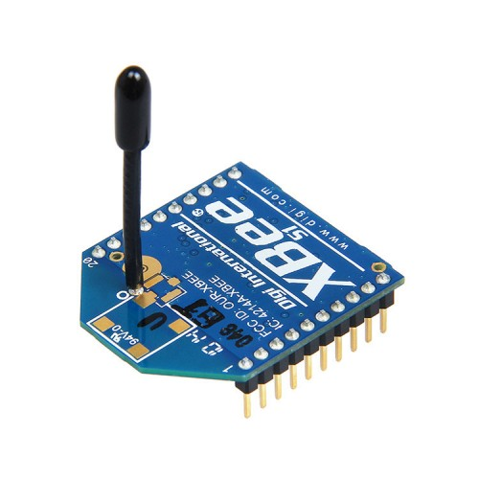

Figure (4.2.1) XBee device

Table (4.2.1) Information about XBee module

|  |  |
| --- | --- |
| Parameter | XBee S2C |
| Input Power | 2.1V to 3.6V |
| Current | 45 mA |
| Distance Coverage | Indoor/Urban: Up to 90 meters, Outdoor/Line of Sight: Up to 1,200 meters |
| Frequency | 2.4 GHz |

### 4.2.2 Water Flow Sensor (YFS02)

The YFS02 water flow sensor is a device used for measuring the rate of water flow in a system. It operates by utilizing a turbine to detect the movement of water, generating electrical pulses in proportion to the flow rate. One important aspect of the YFS02 sensor is its current consumption. It typically consumes approximately 15 milliamperes (mA) of current during operation. This information is crucial for determining the power requirements and electrical compatibility of the sensor within a given system.

. 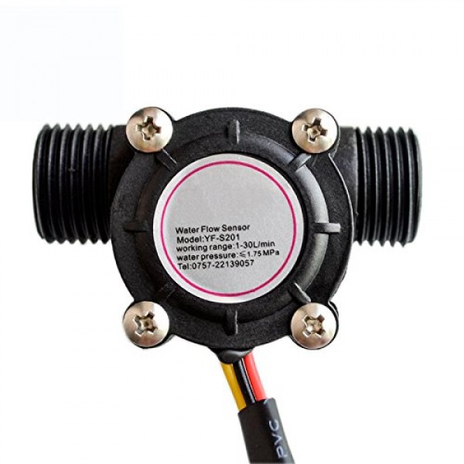

Figure (4.2.2) Flow sensor

Table (4.2.2) Specifications for YFS02 Sensor Measurement

|  |  |  |  |
| --- | --- | --- | --- |
| Water discharge | Current | Temperature | Voltage |
| 1-80 liter/minute | 15mA | 0c-80c | 5v-24v |

### 4.2.3 LCD (Liquid Crystal Display)

The LCD display is a visual feedback and information display commonly used in various electronic devices. It operates by controlling the alignment of liquid crystal molecules to create visible patterns and images. The power consumption of an LCD display can vary based on factors such as screen size, brightness level, and display content.

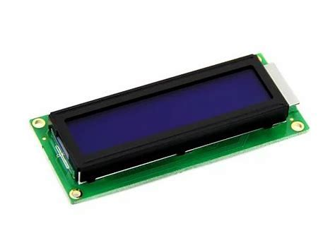

Figure (4.2.3) LCD

### 4.2.4 Arduino Uno

The Arduino Uno serves as the main microcontroller board in the system. It is responsible for data processing, sensor interfacing, and overall system control. The Arduino Uno consumes approximately 232.5 milliwatts of power.

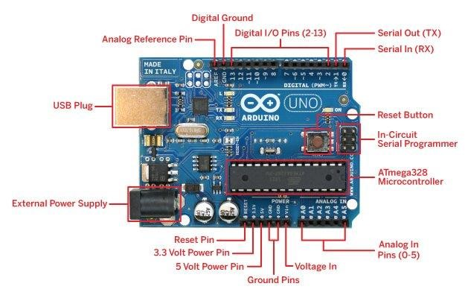

Figure (4.2.4) Arduino Uno

Table (4.2.3) Specification of Arduino uno

|  |
| --- |
| * Microcontroller: ATmega328P * Operating Voltage: 5V * Input Voltage (recommended): 7-12V * In/out Voltage (limit): 6-20V * Digital I/O Pins: 14 (of which 6 provide PWM output) * PWM Digital I/O Pins: 6 * Analog Input Pins: 6 * DC Current per I/O Pin: 20 mA * DC current for 3.3V Pin: 50 mA * Flash Memory:  32 KB (ATmega328P) * SRAM: 2 KB (ATmega328P) * EEPROM:  1 KB (ATmega328P) * Clock Speed:  16 MHz * LED_BUILTIN: 13 * Length: 68.6 mm * Width: 58.4 mm * Weight: 25 g |

### 4.2.5 Water Ultrasonic Sensor (HC-SR04 or Arduino Ultrasonic Sensor)

The water ultrasonic sensor, such as HC-SR04, is used to measure the water level. It consumes approximately 15 milliamperes of current.

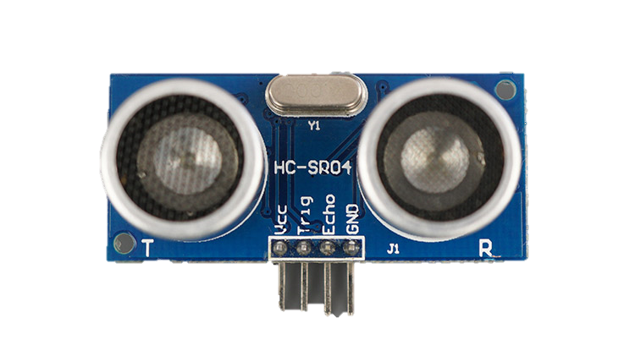

Figure (4.2.5) Ultrasonic sensor

Table (4.2.4) Specifications of ultrasonic sensor

|  |
| --- |
| Operating Voltage 5V  Operating Current 15mA  Operating Frequency 40kHz  Detection Range 2cm - 400cm  Accuracy ±3mm  Trigger Pulse 10μs HIGH pulse  Echo Pulse Width Output duration proportional to  distance  Echo Output TTL level signal  Dimensions 45mm × 20mm × 15mm |

### 4.2.6 Variable Resistor (10k)

A 10k variable resistor, also known as a potentiometer, is used for adjusting and controlling analog signals within the circuit.

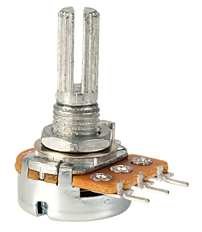

Figure (4.2.6)Variable Resistor (10k)

### 4.2.7 XBEE USB Adapter for XBEE S2C Antenna

The XBEE USB adapter is a versatile device designed to facilitate seamless connectivity between XBEE S2C antennas and computers or microcontrollers. By establishing a reliable connection, it enables efficient programming and facilitates robust communication capabilities. The adapter serves as an intermediary link, allowing users to leverage the full potential of XBEE S2C antennas and harness their wireless capabilities for various applications. Whether it's configuring settings, uploading firmware, or exchanging data, the XBEE USB adapter streamlines the process, providing a convenient and user-friendly solution for integrating XBEE S2C antennas.

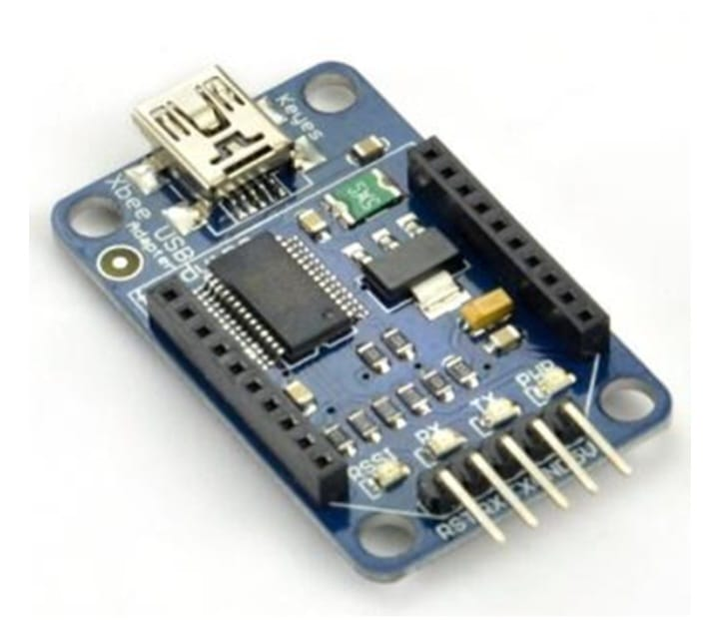

Figure (4.2.7) XBee USB Adapter

### 4.2.8 XBEE Shield

The XBEE shield provides a convenient way to connect and interface the XBEE S2C antennas with the Arduino Uno, enabling seamless communication between the components.

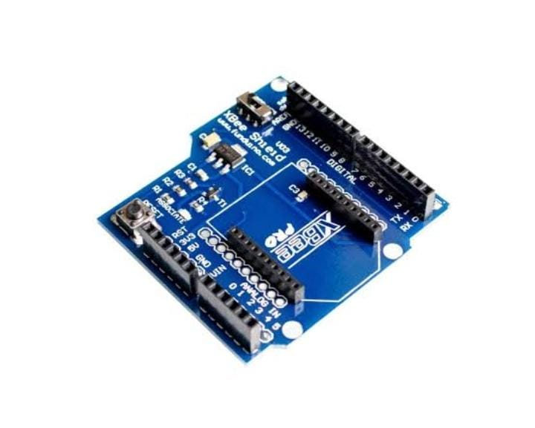

Figure (4.2.8) XBee Shield

### 4.2.9 PCB

An electronic circuit consisting of thin strips of a conducting material such as copper, which have been [etched](https://www.google.com/search?sa=X&bih=597&biw=1242&hl=en&sxsrf=AB5stBgNVah6aLIi8c7ZzXoV2ssQZZqohA:1689493844758&q=etched&si=ACFMAn8Vh8Mk37drt2pTIRWqgL6ejPHRjFOp3YDU43vW1t5HkJV8xzMTyoG4TTeTO-haieKPmx4XgjZvsNlmQ-QZz6HQZoZdSw%3D%3D&expnd=1) from a layer fixed to a flat [insulating](https://www.google.com/search?sa=X&bih=597&biw=1242&hl=en&sxsrf=AB5stBgNVah6aLIi8c7ZzXoV2ssQZZqohA:1689493844758&q=insulating&si=ACFMAn9-5A9OMKPWcg180I9o9MndLyr8EdJUqNwE8-N1sU73Dpw0OPsB6vypQUGhuqSjkkRRi4QxWiuBsEByLwEZ0_fVHjlkow%3D%3D&expnd=1) sheet called a printed circuit board, and to which integrated circuits and other components are attached.

Here we designed a PCB on which sensors and LCD is mounted easily.

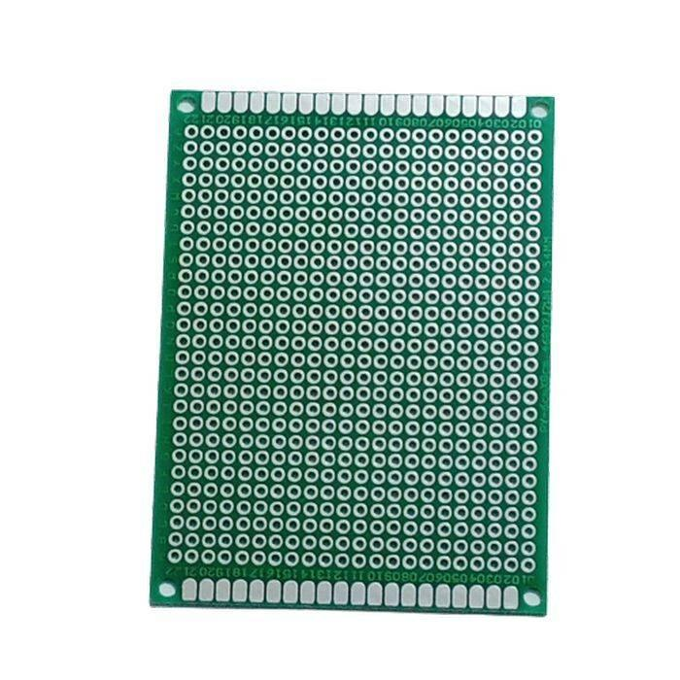

Figure (4.2.9) PCB board

These hardware components, with their respective power consumption and functionalities, form the foundation of the flood monitoring system. They work together to measure water levels, monitor water flow, facilitate wireless communication, and provide visual feedback through the LCD display.

## 4.3 Power Table for all components

|  |  |  |
| --- | --- | --- |
| S no. | Name | Power Consumption |
| 1 | XBEE S2C Antenna | 18.9 milli watts |
| 2 | Water Flow Sensor | 50 milli watts |
| 3 | LCD | 6µW/cm2 |
| 4 | Arduino Uno | 232.5 milli watts |
| 5 | Ultrasonic sensor HC-SR04 | 100 milli watts |

Table (4.3) power table

## 4.4 Block Diagram

A block diagram is like a visual map that shows how different parts of a flood monitoring system are connected. It uses simple shapes and lines to represent the components and the flow of information between them. By looking at the diagram, you can understand how sensors, devices that collect data, are connected to other devices like Arduino Uno, LCD and Xbee wireless module that process the information. It helps people see the big picture and understand how everything works together in the flood monitoring system.

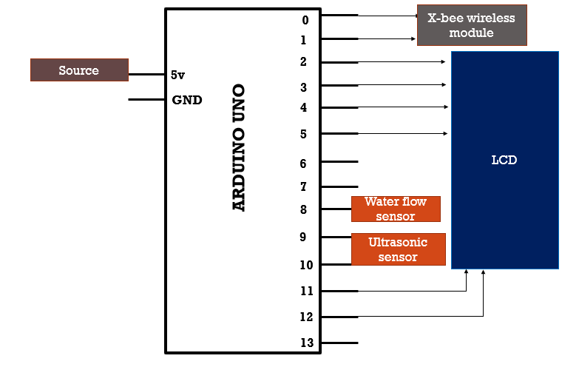

Figure (4.4) Block Diagram

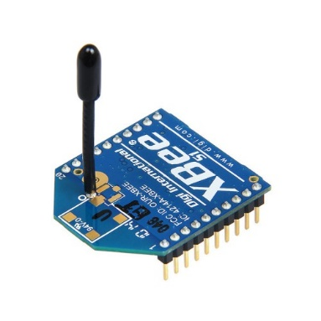

XBee module

IOT

## 4.4 Flow Chart

The flow chart outlines the step-by-step process and decision-making logic followed by the flood monitoring system. It depicts the sequence of actions and interactions between different modules, sensors, and communication protocols. The flow chart provides a clear understanding of the system's operational flow and helps visualize the information processing steps.

**FLOW SENSOR**

**ARDUINO**

**ULTROSONIC SENSOR**

**Coordinator X-BEE**

**LCD**

**Router X-BEE**

**End Device**

Figure (4.4) flow chart

## 4.4 Implementation

This section discusses the practical implementation of the flood monitoring system. It covers the physical assembly of the components, the configuration of software modules, and the integration of different subsystems. The implementation phase involves programming the microcontroller, connecting the sensors and communication modules (XBee), and establishing the necessary interfaces.

During the implementation phase of the system, the following tasks are carried out:

* Microcontroller Programming: The microcontroller is programmed with the necessary code to control the system. Algorithms for data collection, analysis, and communication are developed
* Sensor and XBee Module Connection: Sensors such as water level sensors or rainfall sensors are connected to the microcontroller, along with XBee communication modules. This allows for wireless data transmission between the sensors and the microcontroller.
* Software module configuration: During the software module configuration phase, the flood monitoring system's software components are set up to perform specific functions. This involves adjusting settings, calibrating sensors for accurate readings, and for wirelessly transferring the sensors data to other nodes.

|  |  |
| --- | --- |
|  |  |

Figure (4.4) Circuit implementation

#### 4.4.1 Testing

Testing is an essential part of the implementation process to ensure the proper functioning and accuracy of the system. The testing phase is divided into two parts: hardware testing and software testing.

#### 4.4.1.1 Hardware Testing

Hardware testing involves verifying the functionality and reliability of the physical components used in the flood monitoring system. Each component, such as the water flow and ultrasonic sensor, XBEE S2C antennas, LCD display, variable resistor, Arduino Uno, and water flow sensor, is tested individually and in conjunction with the overall system. This testing ensures that the hardware components are correctly connected, calibrated, and operational.

#### 4.4.1.2 Software Testing

Software testing focuses on validating the functionality and performance of the software modules used in the flood monitoring system. The software, including the program running on the Arduino Uno microcontroller and any accompanying algorithms or logic, is tested to ensure it accurately processes the data from the sensors, communicates with the XBEE antennas, and displays the information on the LCD. Various test scenarios and data inputs are used to assess the software's reliability and effectiveness.

By conducting thorough testing, both hardware and software, the flood monitoring system can be verified for its reliability, accuracy, and overall performance. Any issues or inconsistencies identified during testing can be addressed and resolved to ensure the system operates as intended.

Overall, Chapter 4 provides insights into the design and implementation process of the flood monitoring system. It describes the system's architecture through the block diagram, illustrates the operational flow using the flow chart, and explains the steps taken for hardware and software testing. This chapter sets the foundation for the subsequent chapters, where the results, discussions, and conclusions of the flood monitoring system will be presented.

# **CHAPTER 05**

# **Result and Discussion**

## 5 Introduction

This chapter presents the results and discussions of the flood monitoring system using Wireless Sensor Network (WSN) and Internet of Things (IoT). This chapter provides a comprehensive analysis of the software and actual hardware results obtained from the implementation of the system. Theoretical and practical backgrounds are discussed, along with the techniques utilized to develop and deploy the system.

## 5.1 Actual Hardware Results

This section focuses on the actual hardware implementation of the flood monitoring system. Each component used in the project is explained in detail:

### 5.1.1 Water Ultrasonic Sensor (HC-SR04 or Arduino Ultrasonic Sensor):

### The water ultrasonic sensor is responsible for measuring the distance between the sensor and the water surface. It uses ultrasonic waves to calculate the time taken for the waves to bounce back, providing accurate water level measurements.

### 5.1.2 Water Flow Sensor (YFS02):

### The water flow sensor measures the rate of water flow in the system. It detects the pulses generated by the flowing water, allowing for monitoring and measurement of water flow.

### 5.1.3 Arduino Uno:

The Arduino Uno is a microcontroller board that serves as the central processing unit of the flood monitoring system. It reads data from the sensors, controls the XBEE communication, and manages the display on the LCD.

### 5.1.4 LCD Crystal:

The LCD crystal is a display module that provides visual feedback and information. It can show various parameters such as water level, system status, or error messages, enhancing the usability of the system.

### 5.1.5 Variable Resistor (10k):

The 10k variable resistor, also known as a potentiometer, is used for adjusting and controlling analog signals within the circuit. It can be used for fine-tuning certain parameters or calibrating sensors.

### 5.1.5 XBEE S2C Antennas (Coordinator, Router, and End-Device):

### The project utilizes three XBEE S2C antennas for wireless communication within the sensor network. The Coordinator acts as the network manager, the Router facilitates data transmission between nodes, and the End-Device collects data from sensors. These antennas enable multi-hopping, allowing data to be transmitted over multiple nodes.

### 5.1.6 XBEE USB Adapter:

The XBEE USB adapter is used to connect the XBEE S2C antennas to a computer or microcontroller for programming and communication purposes.

5.1.7 Hardware Results:

The hardware output is shown below in fig.

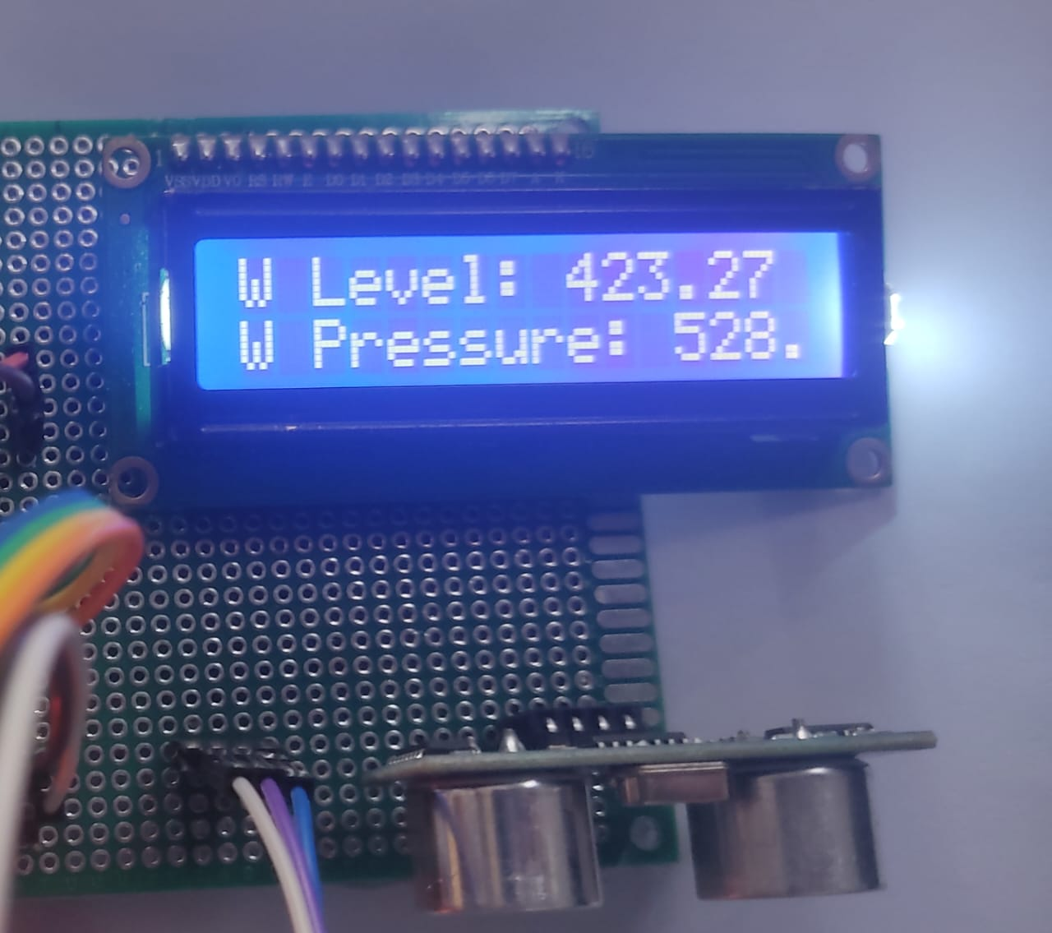

Figure (5.1.7) LCD output

5.2 Software Results

The software results of the flood monitoring system, which utilizes an ultrasonic sensor for water level measurement and flow pressure, along with the wireless XBee module, integrated with Arduino Uno and XCTU software, provide valuable information for flood monitoring and management.

By analyzing the data collected from the ultrasonic sensor, the software calculates the water level in real-time. This information is crucial for assessing the severity of flooding and determining appropriate response measures. The software also measures the flow pressure, allowing for insights into the rate of water movement, which aids in understanding flood dynamics.

Through the integration of Arduino Uno and XCTU software, the flood monitoring system can efficiently process the sensor data, perform necessary calculations, and establish wireless communication using the XBee module. This enables seamless transmission of data to a central control station or monitoring center, facilitating remote monitoring and prompt decision-making.

The software results of the flood monitoring system, utilizing ultrasonic sensor measurements, flow pressure calculations, and the wireless XBee module, offer accurate and real-time insights into flood conditions.

* Software Results:

The output of sensors on serial monitor is shown below in fig.

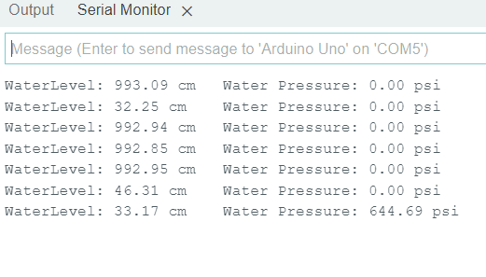

Figure (5.2.1) Serial monitor output

Results on XCTU Console log:

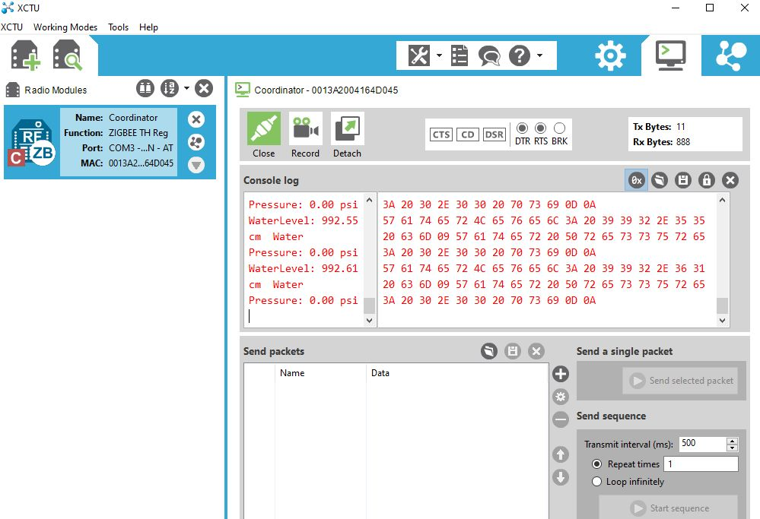

Figure (5.2.2) output on coordinator XBee

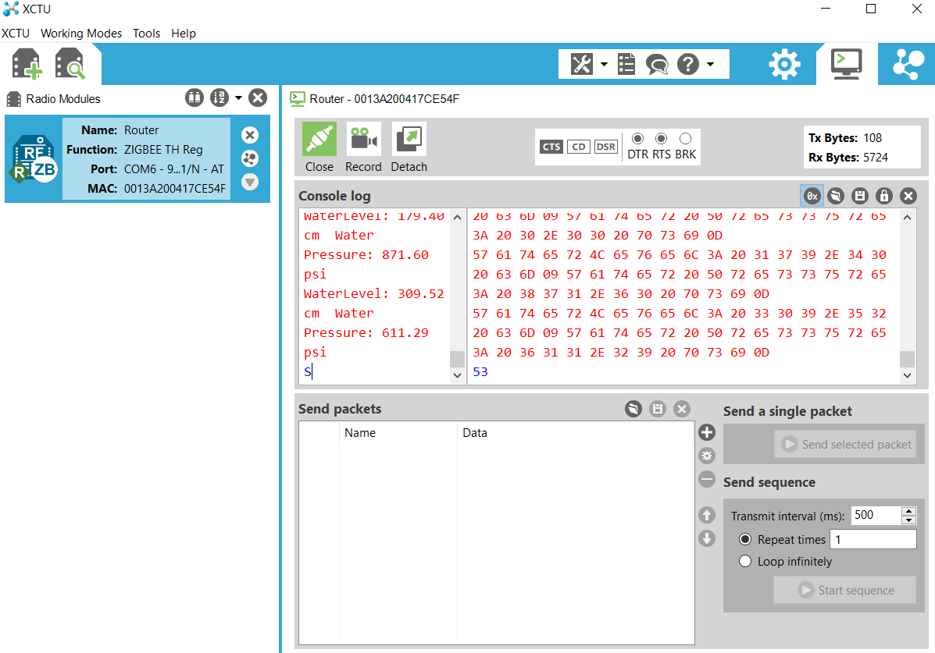

Figure (5.2.2) output on router XBee



## Figure (5.2.2) output on end device

## 5.3 Discussion

The discussion section provides an in-depth analysis and interpretation of the results obtained from both the software and actual hardware implementations. The findings are discussed in relation to the research objectives and research questions stated in Chapter 1. The strengths, weaknesses, and limitations of the flood monitoring system are identified and addressed. The theoretical and practical background of the system, including the principles of ultrasonic sensing, XBEE communication, and data visualization on the LCD, are revisited to provide context for the discussion. The techniques used to implement and integrate the components are discussed, highlighting any challenges, solutions, or improvements made during the process.

## 5.4 Comparative Analysis

## In this comparative analysis, the performance of the hardware implementation, which includes an LCD display for a flood monitoring system utilizing flow and ultrasonic sensors, is assessed alongside the results displayed on the XCTU software. The goal is to identify any disparities or variations between the two datasets and explore potential reasons for these differences. Additionally, the advantages and limitations of using the XCTU software in conjunction with real-world hardware for flood monitoring are also discussed. Firstly, the performance of the hardware implementation is evaluated. The flow and ultrasonic sensors are responsible for gathering data related to water levels and flow rates. These sensors provide direct measurements based on real-time environmental conditions. The gathered data is then processed by the hardware components, including microcontrollers and signal conditioning circuits, to generate meaningful information for display on the LCD screen. The LCD display presents key information such as water level, flow rate.

## Simultaneously, the XCTU software plays a crucial role in monitoring and visualizing the collected data. XCTU acts as a comprehensive platform for configuring, managing, and troubleshooting wireless devices. It allows for real-time monitoring of sensor readings, communication parameters, and network performance. The software receives the data transmitted by the hardware components and provides a graphical representation of the flood monitoring system's status and measurements.

## During the comparative analysis, any discrepancies between the hardware implementation and the XCTU software results are carefully examined. Potential factors contributing to these differences could include sensor calibration issues, environmental factors influencing sensor performance, signal transmission and reception issues, or inaccuracies in the data processing algorithms employed by the hardware. Such variations need to be thoroughly investigated to ensure the accuracy and reliability of the flood monitoring system.

## 5.5 Conclusion

Chapter 5 concludes with a summary of the results and discussions presented in this chapter. The key findings, implications, and contributions of the flood monitoring system using WSN and IoT are highlighted. The chapter emphasizes the importance of the simulated and actual hardware results in evaluating the system's performance, functionality, and feasibility. It also lays the foundation for Chapter 5, where recommendations, improvements, and future directions for the flood monitoring system will be discussed.

Chapter 5 provides a comprehensive analysis of the software and actual hardware results of the flood monitoring system. The discussion critically evaluates the performance, limitations, and unique aspects of the system, shedding light on its effectiveness in addressing the challenges of flood monitoring.

# CHAPTER 06

# CONCLUSIONS AND FUTURE Work

## 6.1 Important Findings

In this section, the important findings of the flood monitoring system using Wireless Sensor Network (WSN) and Internet of Things (IoT) are highlighted. The key discoveries, insights, and contributions of the research are summarized. The findings from both the results on actual hardware and software are considered, providing a comprehensive understanding of the system's performance, accuracy, and effectiveness in flood monitoring.

## 6.2 Conclusion

It concludes the study by summarizing the main outcomes and achievements of the project. The conclusion reflects upon the objectives and research questions outlined in Chapter 1. It discusses the overall success and feasibility of the flood monitoring system, taking into account the results, hardware implementation, and discussions presented in the previous chapters.

The flood monitoring system has demonstrated its capability to accurately measure water levels using the water ultrasonic sensor, monitor water flow using the water flow sensor, and transmit data wirelessly using the XBEE S2C antennas. The integration of these components, coupled with the use of the Arduino Uno microcontroller and LCD display, has provided a robust and efficient solution for real-time flood monitoring.

The system's performance and reliability have been evaluated and validated through simulated and actual hardware testing. The comparative analysis between the simulated and actual results has revealed a high degree of accuracy, with the simulated results closely aligning with the actual hardware measurements.

## 6.3 Limitations of the System

Despite the successes of the flood monitoring system, it is essential to acknowledge its limitations. Some of the limitations include:

* Limited range of the wireless communication between XBEE antennas: The range of the XBEE S2C antennas is influenced by various factors such as obstacles, interference, and environmental conditions. This may restrict the coverage area of the system.
* Dependency on power source: The system's functionality relies on a stable power source. In cases of power outages or disruptions, the system may experience downtime or be unable to operate effectively.
* Sensitivity to environmental factors: The performance of the water ultrasonic sensor and water flow sensor may be affected by external factors such as temperature, humidity, and water quality. Calibrations and regular maintenance may be required to ensure accurate measurements.

## 6.4 Future Recommendations

Based on the findings and limitations identified, several recommendations can be made for future enhancements and developments of the flood monitoring system:

* Integration of additional sensors: Expanding the system's capabilities by incorporating sensors for monitoring other environmental parameters such as rainfall, humidity, and water quality. This would provide a more comprehensive understanding of flood conditions.
* Implementation of advanced data analysis techniques: Applying machine learning algorithms and data analytics to the collected data can enable predictive modeling and early warning systems for flood events. This would enhance the system's ability to anticipate and mitigate potential risks.
* Enhancing wireless communication capabilities: Exploring alternative wireless communication protocols or technologies that offer longer range and improved stability, enabling the system to cover larger areas and operate in challenging terrains.
* Integration with a centralized monitoring system: Developing a centralized monitoring platform that can receive, process, and visualize data from multiple flood monitoring systems. This would enable efficient data management, decision-making, and coordination during flood events.
* Deployment in real-world scenarios: Conducting field trials and deploying the system in real-world flood-prone areas to evaluate its performance, reliability, and scalability. This would provide valuable insights and feedback for further improvements.

By addressing these recommendations, the flood monitoring system can be enhanced to provide more accurate and comprehensive flood monitoring capabilities. These improvements will contribute to better flood management and disaster response strategies, ultimately minimizing the impact of floods on communities and infrastructure.

In conclusion, the flood monitoring system using WSN and IoT has demonstrated its potential in accurately measuring water levels, monitoring water flow, and facilitating data transmission. The system's effectiveness has been confirmed through both simulated and actual hardware results. Although there are limitations, the future recommendations offer valuable insights for further development and enhancement of the system. The overall contribution of this research lies in its potential to improve flood monitoring, early warning systems, and flood management strategies.

# 

# References

[1] Cattoën, C., McMillan, H. and Moore, S., “Coupling a high-resolution weather model with a hydrological model for flood forecasting in New Zealand”. Journal of Hydrology, Vol. 55, No. 1, pp.1, 2016.

[2] Aggarwal, A., Jain, S.K., Lohani, A.K. and Jain, N., “Glacial lake outburst flood risk assessment using combined approaches of remote sensing, GIS and dam break modelling”. Geomatics, Natural Hazards and Risk, Vol. 7, No. 1, pp.18-36, 2016.

[3] Baugh, C., Pappenberger, F., Wetterhall, F., Hewson, T. and Zsoter, E., “A global flash flood forecasting system”. In EGU General Assembly Conference Abstracts, Vol. 18, pp. 8529, 2016.

[4] Mahmood, S. and Ullah, S., “Assessment of 2010 flash flood causes and associated damages in Dir Valley, Khyber Pakhtunkhwa Pakistan”. International Journal of Disaster Risk Reduction, Vol. 16, pp.215-223, 2016.

[5] Khan, F., Memon, S., Jokhio, I.A. and Jokhio, S.H., “November. Wireless sensor network based flood/drought forecasting system”. In IEEE SENSORS, pp. 1-4., 2015.

[6] Jiang, P., Xia, H., He, Z. and Wang, Z., “Design of a water environment monitoring system based on wireless sensor networks”. Sensors, Vol. 9, No. 8, pp.6411-6434, 2009.

[7] Priyadarshinee, I., Sahoo, K. and Mallick, C., “Flood prediction and prevention through wireless sensor networking (wsn): A survey”. International Journal of Computer Applications, Vol. 113, No. 9, 2015.

[8] Akyildiz, I.F., Su, W., Sankarasubramaniam, Y. and Cayirci, E., “Wireless sensor networks: a survey”. Computer networks, Vol. 38, No.4, pp.393-422, 2002.

[9] Intharasombat, O. and Khoenkaw, P., “A low-cost flash flood monitoring system”. In 2015 7th International Conference on Information Technology and Electrical Engineering (ICITEE), pp. 476-479, 2015.

[10] Wan, Z.G., Tan, Y.K. and Yuen, C., “Review on energy harvesting and energy management for sustainable wireless sensor networks”. In Communication Technology (ICCT), 2011 IEEE 13th International Conference on, pp. 362-367, 2011.

[11] Vullers, R., Schaijk, R., Visser, H., Penders, J. and Hoof, C., “Energy harvesting for autonomous wireless sensor networks”. IEEE Solid-State Circuits Magazine, Vol. 2, No. 2, pp.29-38, 2010.

[12] Younis, M., Senturk, I.F., Akkaya, K., Lee, S. and Senel, F., “Topology management techniques for tolerating node failures in wireless sensor networks: A survey”. Computer Networks, Vol. 58, pp.254-283, 2014.

# Appendices

## Code of Sensor and XBEE

|  |
| --- |
| #include <Wire.h> // Include the Wire library for I2C  #include <LiquidCrystal.h> // Include the LCD library  #include <SoftwareSerial.h> // Include the SoftwareSerial library  #include <XBee.h>  // Define the pins for the ultrasonic sensor  const int trigPin = 9;  const int echoPin = 10;  // Define the pin for the water flow sensor  const int flowPin = 8;  // Define pins for LiquidCrystal lcd  const int rs = 12;  const int en = 11;  const int d4 = 5;  const int d5 = 4;  const int d6 = 3;  const int d7 = 2;  // Define the LCD dimensions  const int lcdColumns = 16;  const int lcdRows = 2;  // Initialize LCD screen  LiquidCrystal lcd(rs, en, d4, d5, d6, d7);  // Create an instance of the XBee class  XBee xbee;  // Create a SoftwareSerial object for communication with the XBee module  SoftwareSerial xbeeSerial(2, 3); // RX, TX (avoid using pins 0 and 1)  void setup() {  // Initialize the serial communication  Serial.begin(9600);  // Initialize the XBee module  xbeeSerial.begin(9600);  // Initialize the LCD  lcd.begin(lcdColumns, lcdRows);  lcd.clear();  lcd.setCursor(0, 0);  // Set the pin modes  pinMode(trigPin, OUTPUT);  pinMode(echoPin, INPUT);  pinMode(flowPin, INPUT);  }  void loop() {  // Read the water level from the ultrasonic sensor  float waterLevel = readWaterLevel();  // Read the water pressure from the water flow sensor  float waterPressure = readWaterPressure();  // Print the data to the serial monitor  Serial.print("Water Level: ");  Serial.print(waterLevel);  Serial.print(" cm\t");  Serial.print("Water Pressure: ");  Serial.print(waterPressure);  Serial.println(" psi");  // Display the data on the LCD  lcd.clear();  lcd.setCursor(0, 0);  lcd.print("W Level: ");  lcd.print(waterLevel);  lcd.print(" cm");  lcd.setCursor(0, 1);  lcd.print("W Pressure: ");  lcd.print(waterPressure);  lcd.print(" psi");  // Send the data to the XBee module in transparent mode  sendDataToXBee(waterLevel, waterPressure);  delay(1000);  }  float readWaterLevel() {  // Send a pulse to the trigPin  digitalWrite(trigPin, LOW);  delayMicroseconds(2);  digitalWrite(trigPin, HIGH);  delayMicroseconds(10);  digitalWrite(trigPin, LOW);  // Read the duration of the echoPin pulse  float duration = pulseIn(echoPin, HIGH);  // Calculate the water level based on the speed of sound  float waterLevel = duration * 0.034 / 2;  return waterLevel;  }  float readWaterPressure() {  // Read the frequency from the flowPin  int frequency = pulseIn(flowPin, HIGH);  // Convert the frequency to water pressure (adjust based on your sensor's specifications)  float waterPressure = frequency * 0.132; // Example calibration value  return waterPressure;  }  void sendDataToXBee(float waterLevel, float waterPressure) {  xbeeSerial.print("Water Level: ");  xbeeSerial.print(waterLevel);  xbeeSerial.print(" cm, ");  xbeeSerial.print("Water Pressure: ");  xbeeSerial.print(waterPressure);  xbeeSerial.println(" psi");  } |